**A Call For More Blood Shed?**

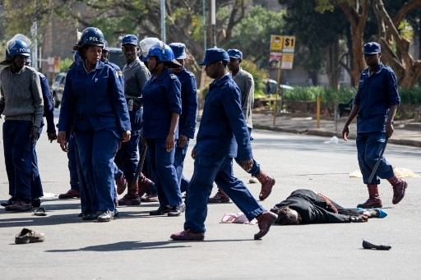

The netizens of Zimbabwe caused an uproar on twitter as they united against ZANU PF. This led the president of Zimbabwe to call for a media conference in a panicked response to address the nation. As such, his speech left much to be desired, because no man joe issues were addressed except for one.

It is laughable that any person that openly disagrees with the way ZANU PF govern the country is to be labelled a terrorist. This would extend beyond the opposition and In fact include a lot of citizens of the country to be put in to this category of ‘dark forces’ and ‘bad apples’. On top of extreme measures such as arresting, torturing and even killing civilians to suppress their rights to free speech. They have become so deluded and self absorbed in their ill-gotten wealth that they do not care about what the ordinary Zimbabwean must got through to survive a day in Zimbabwe.

If anyone is a terrorist, it is Mnangagwa and his cronies because they carry the blood of innocent people they have killed over the years. The sheer terror he has unleashed on the streets and in people’s is terrifying.

How can an ordinary citizen keep quiet when basic necessities such as health care, food and unbiased judicial system have not been available to most of the nation? Every human being should be able to freely express themselves especially if their livelihood is at stake.

Anesu Munyama

MDC UK